Model Report

Starter Sequence Diagram

Version 1.0 ● Proposed
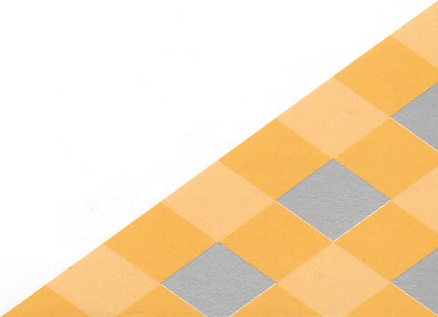 | Date/Time Generated: | 4/8/2025 11:04:21 AM
 | Author: | anas

EA Repository : C:\Users\anas\Desktop\PFE\MLD\PFE_sequence.eapx
CREATED WITH | 

Starter Sequence Diagram
Package in package 'Model'

Starter Sequence Diagram
Version 1.0 Phase 1.0 Proposed
Bilel created on 3/22/2025. Last modified 1/30/2018

Starter Sequence Diagram diagram
Interaction diagram in package 'Starter Sequence Diagram'

Starter Sequence Diagram
Version 1.0
Boughanmi created on 3/22/2025. Last modified 4/8/2025

- Starter Sequence Diagram

INTERACTION MESSAGES
1.0 'lancer l'application()' from 'User' sent to 'Accueil'.

Synchronous Call. Returns void.
[ Return is False. Iteration is False. New group is False. ]

1.1 'Afficher la page d'accueil' from 'Accueil' sent to 'User'.

Synchronous Call. Returns void.
[ Return is False. Iteration is False. New group is False. ]

1.2 'Demande de connexion:Login' from 'User' sent to 'Authentification'.

Synchronous Call. Returns void.
[ Return is False. Iteration is False. New group is False. ]

1.3 'Affihcer' from 'Authentification' sent to 'User'.

Synchronous Call. Returns void.
[ Return is False. Iteration is False. New group is False. ]

1.4 'Saisir' from 'User' sent to 'Authentification'.

Synchronous Call. Returns void.
[ Return is False. Iteration is False. New group is False. ]

1.5 'Vérifier' from 'Authentification' sent to 'Authentification'.

Synchronous Call. Returns void.
[ Return is False. Iteration is False. New group is False. ]

1.6 'Envoyer' from 'Authentification' sent to 'Serveur base de données '.

Synchronous Call. Returns void.
[ Return is False. Iteration is False. New group is False. ]

1.7 'Vérification' from 'Serveur base de données ' sent to 'Serveur base de données '.

Synchronous Call. Returns void.
[ Return is False. Iteration is False. New group is False. ]

1.8 'Authentification' from 'Serveur base de données ' sent to 'Authentification'.

Synchronous Call. Returns void.
[ Return is False. Iteration is False. New group is False. ]

1.9 'Se connecter()' from 'Authentification' sent to 'Session User'.

Synchronous Call. Returns void.
[ Return is False. Iteration is False. New group is False. ]

User
Actor in package 'Starter Sequence Diagram'

User
Version 1.0 Phase 1.0 Proposed
Bilel created on 3/22/2025. Last modified 4/8/2025

OUTGOING BEHAVIORAL RELATIONSHIPS
Name: lancer l'application()
Sequence from User to Accueil

Name: Demande de connexion:Login
Sequence from User to Authentification

Name: Saisir
Sequence from User to Authentification

INCOMING BEHAVIORAL RELATIONSHIPS
Name: Afficher la page d'accueil
Sequence from Accueil to User

Name: Affihcer
Sequence from Authentification to User

Accueil
Sequence in package 'Starter Sequence Diagram'

Accueil
Version 1.0 Phase 1.0 Proposed
anas created on 4/8/2025. Last modified 4/8/2025

OUTGOING BEHAVIORAL RELATIONSHIPS
Name: Afficher la page d'accueil
Sequence from Accueil to User

INCOMING BEHAVIORAL RELATIONSHIPS
Name: lancer l'application()
Sequence from User to Accueil

Authentification
Sequence in package 'Starter Sequence Diagram'

Authentification
Version 1.0 Phase 1.0 Proposed
Bilel created on 3/22/2025. Last modified 3/22/2025

OUTGOING BEHAVIORAL RELATIONSHIPS
Name: Se connecter()
Sequence from Authentification to Session User

Name: Vérifier
Sequence from Authentification to Authentification

Name: Envoyer
Sequence from Authentification to Serveur base de données

Name: Affihcer
Sequence from Authentification to User

INCOMING BEHAVIORAL RELATIONSHIPS
Name: Authentification
Sequence from Serveur base de données to Authentification

Name: Vérifier
Sequence from Authentification to Authentification

Name: Demande de connexion:Login
Sequence from User to Authentification

Name: Saisir
Sequence from User to Authentification

Serveur base de données
Sequence in package 'Starter Sequence Diagram'

Serveur base de données
Version 1.0 Phase 1.0 Proposed
Bilel created on 3/22/2025. Last modified 3/22/2025

OUTGOING BEHAVIORAL RELATIONSHIPS
Name: Vérification
Sequence from Serveur base de données to Serveur base de données

Name: Authentification
Sequence from Serveur base de données to Authentification

INCOMING BEHAVIORAL RELATIONSHIPS
Name: Vérification
Sequence from Serveur base de données to Serveur base de données

Name: Envoyer
Sequence from Authentification to Serveur base de données

Session User
Sequence in package 'Starter Sequence Diagram'

Session User
Version 1.0 Phase 1.0 Proposed
Bilel created on 3/22/2025. Last modified 4/8/2025

INCOMING BEHAVIORAL RELATIONSHIPS
Name: Se connecter()
Sequence from Authentification to Session User

